**Chapter 3: SYSTEM DEVELOPMENT**

3.1 Requirement Specification

The System need the Decision Support System in Which we need to Have the three module as Follows:

1. NK1
2. NK2
3. PMRD
4. 4.FINAL REPORT

As system need to take the Daily activity of the users or Employees that all perspective that Wheather users is doing completion of work on time,complication of the dispatch works, completion of the sheets, presentation. Whether the users is doing the on time dilevary .

The second module is the report of the Users on Monthly bases that the output of the daily will be taken from the report of the NK1 and is Input for the NK2 ,

In NK2 the Admin will get to know About the Employee s monthly performances.

The Three module is the PMRD in which we will get to know that the combine the all the NK1 And NK2 and the evaluation of the Annual is done in PMRD module .In which the users All over Year performance is get to know by the head of the company , and will be helpful for the best employee too know the company. The Important module is the the fourth one in which will display the whole of the Employee to get to know about the Employee of the company. The Additional part is the Here we Also get to know the the other ciriculum activities too.

3.2: Implementation:

* C# Language

Basically we are going to develop a standalone application for this industry. As per the industrial requirements to develop this application we are using C# language and .Net framework and Microsoft SQL Server for database. C# Language C# syntax is highly expressive, yet it is also simple and easy to learn. The curly-brace syntax of C# will be instantly recognizable to anyone familiar with C, C++ or Java. Developers who know any of these languages are typically able to begin to work productively in C# within a very short time.

C# syntax simplifies many of the complexities of C++ and provides powerful features such as nullable value types, enumerations, delegates, lambda expressions and direct memory access, which are not found in Java. C# supports generic methods and types, which provide increased type safety and performance, and iterators, which enable implementers of collection classes to define custom iteration behaviors that are simple to use by client code. Language-Integrated Query (LINQ) expressions make the strongly-typed query a first-class language construct.

* Net Framework

C# programs run on the .NET Framework, an integral component of Windows that includes a virtual execution system called the common language runtime (CLR) and a unified set of class libraries. The CLR is the commercial implementation by Microsoft of the common language infrastructure (CLI), an international standard that is the basis for creating execution and development environments in which languages and libraries work together seamlessly. Source code written in C# is compiled into an intermediate language (IL) that conforms to the CLI specification. The IL code and resources, such as bitmaps and strings, are stored on disk in an executable file called an assembly, typically with an extension of .exe or .dll. An assembly contains a manifest that provides information about the assembly's types, version, culture, and security requirements.

In addition to the run time services, the .NET Framework also includes an extensive library of over 4000 classes organized into namespaces that provide a wide variety of useful functionality for everything from file input and output to string manipulation to XML parsing, to Windows Forms controls. The typical C# application uses the .NET Framework class library extensively to handle common "plumbing" chores.

* Microsoft SQL Server :

SQL Server is Microsoft's relational database management system (RDBMS). It is a full-featured database primarily designed to compete against competitors Oracle Database (DB) and MySQL. Like all major RDBMS, SQL Server supports ANSI SQL, the standard SQL language. However, SQL Server also contains T-SQL, its own SQL implementation. SQL Server Management Studio (SSMS) (previously known as Enterprise Manager) is SQL Server's main interface tool, and it supports 32-bit and 64-bit environments. SQL Server is sometimes referred to as MSSQL and Microsoft SQL Server. SQL Server is offered in several editions with different feature set and pricing options to meet a variety of user needs, including the following:

* Enterprise:

Designed for large enterprises with complex data requirements, data warehousing and Web-enabled databases. Has all the features of SQL Server, and its license pricing is the most expensive.

* Standard:

Targeted toward small and medium organizations. Also supports e-commerce and data warehousing.

* Workgroup:

For small organizations. No size or user limits and may be used as the backend database for small Web servers or branch offices.

* Express:

Free for distribution. Has the fewest number of features and limits database size and users. May be usedas a replacement for an Access database.

3.3 DFD

3.3.1 DFD LEVEL 1

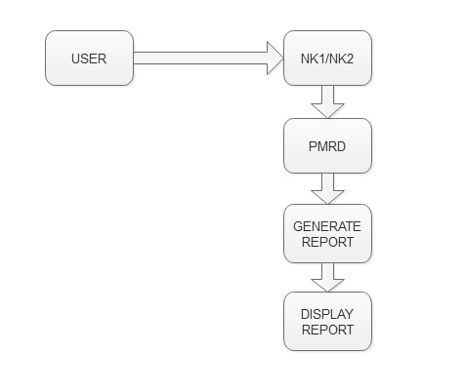

**Figure 3.3.1 DFD LEVEL 1**

As system need to take the Daily activity of the users or Employees that all perspective that Wheather users is doing completion of work on time,complication of the dispatch works, completion of the sheets, presentation. Whether the users is doing the on time delivery .

3.3.2 DFD LEVEL 2

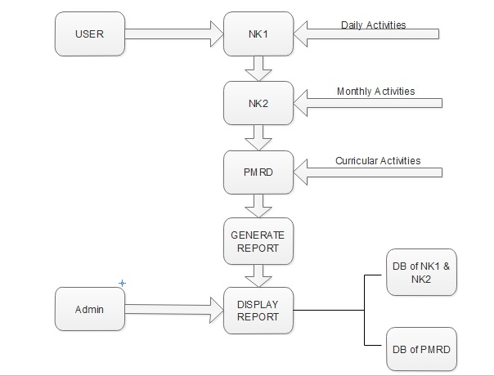

**Figure 3.3.2 DFD LEVEL 2**

The second module is the report of the Users on Monthly bases that the output of the daily will be taken from the report of the NK1 and is Input for the NK2 .In NK2 the Admin will get to know About the Employee s monthly performances.

3.4 UML Diagrams

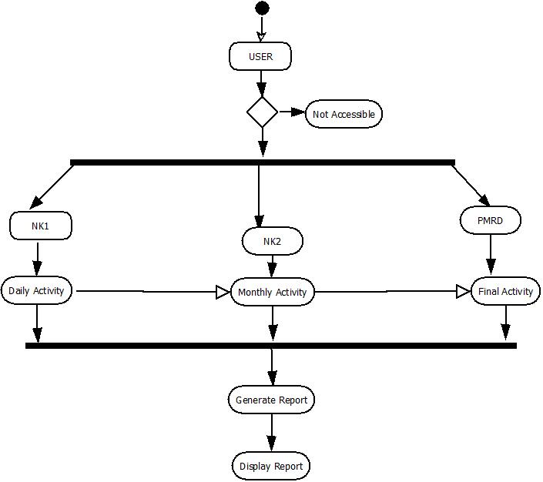

**Figure 3.4.1 Activity Diagram**

The Three module is the PMRD in which we will get to know that the combine the all the NK1 And NK2 and the evaluation of the Annual is done in PMRD module .In which the users All over Year performance is get to know by the head of the company , and will be helpful for the best employee too know the company. The Important module is the the fourth one in which will display the whole of the Employee to get to know about the Employee of the company. The Additional part is the Here we Also get to know the the other ciriculum activities too.

3.5 Use Case Diagram

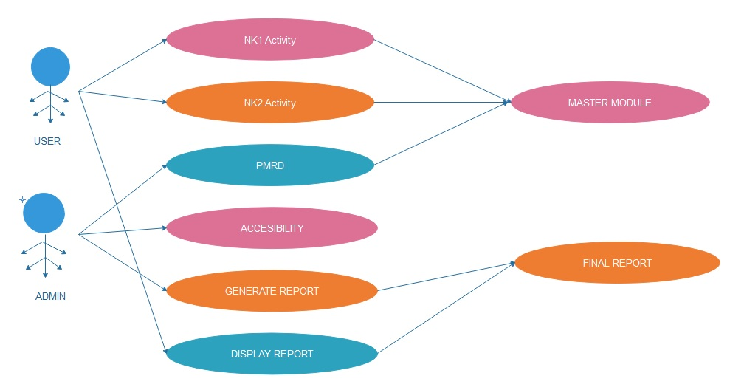

**Figure 3.5.1 Use Case Diagram**